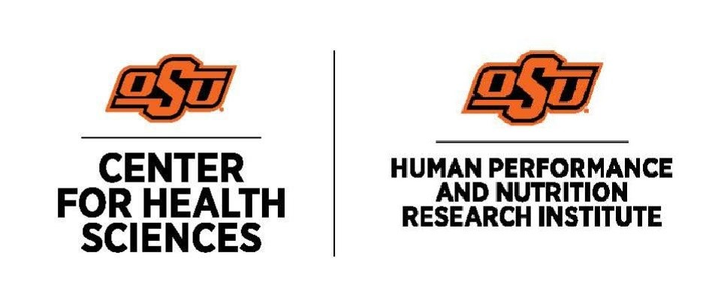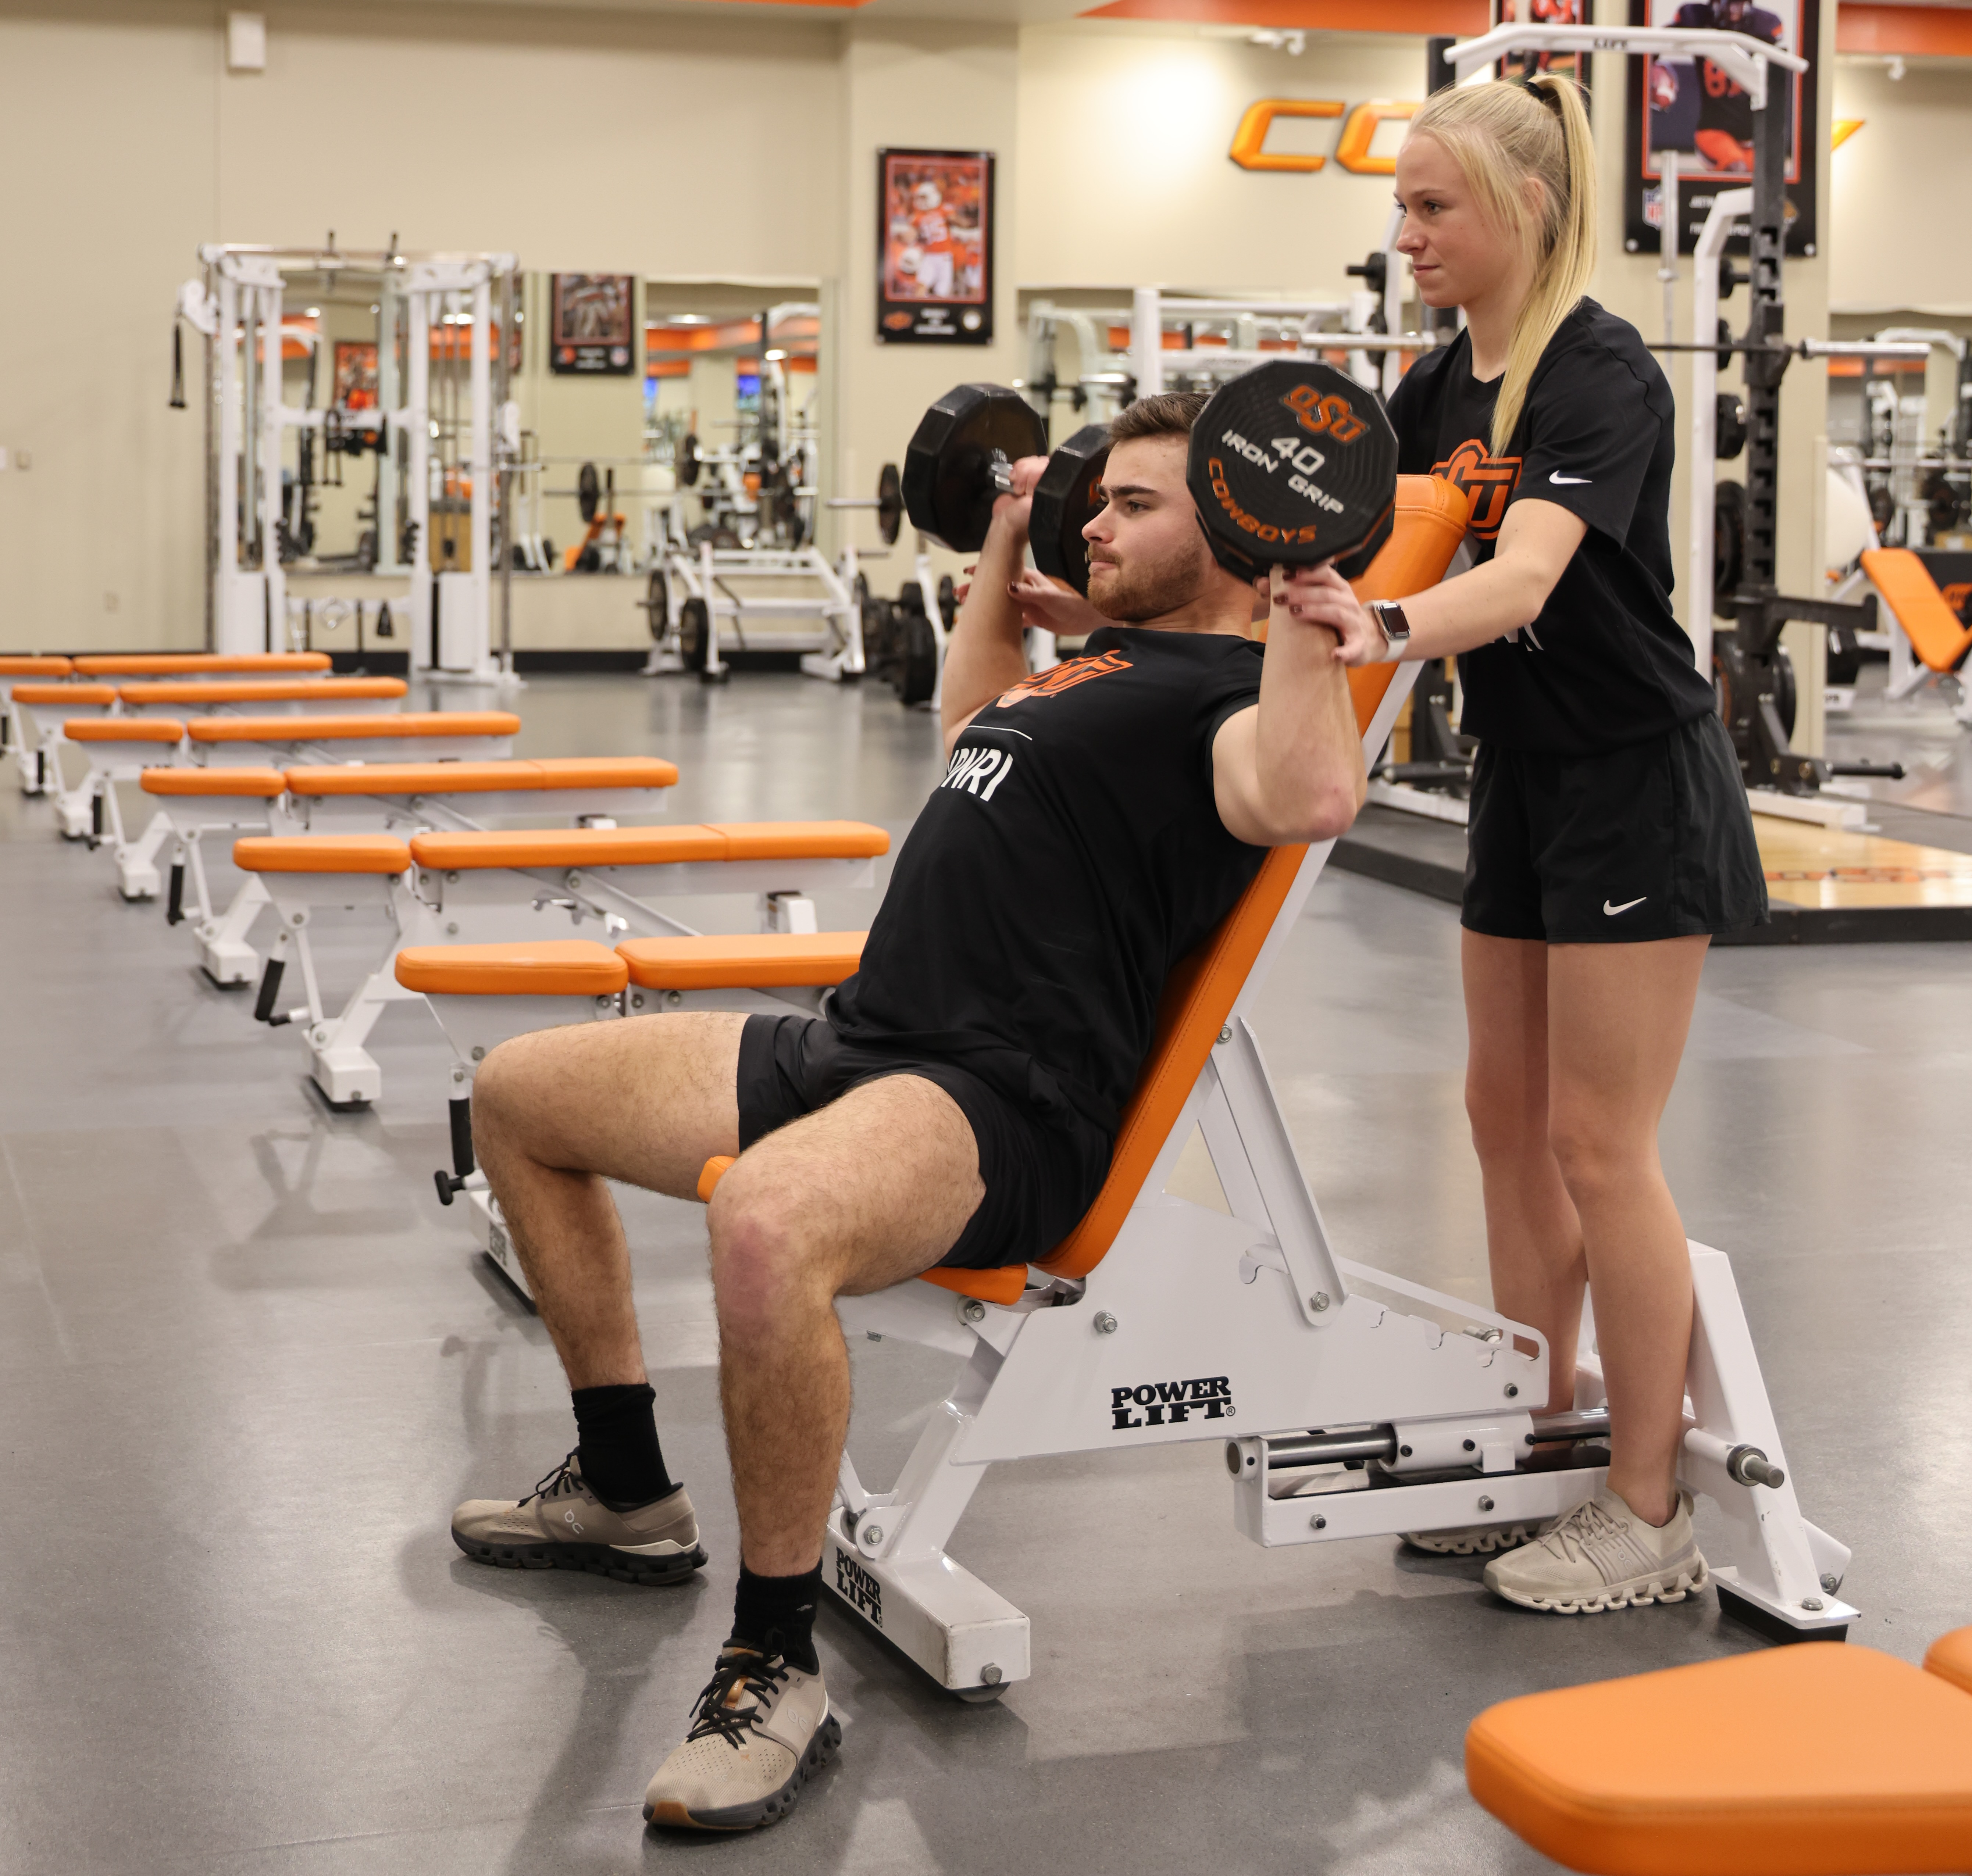  The Science Behind Popular Diets  Learning Objectives  1. Understand the dietary quality and nutritional adequacy of popular diets.  2. Evaluate the pros and cons of popular diets in relation to the health and performance of your athletes.  3. Identify popular diets that are not appropriate for your athlete group.  Schedule and Format  - Wednesday, February 18, 2026; 12-1:00pm  Cancellation/Refund Policy  - None. No payments necessary.  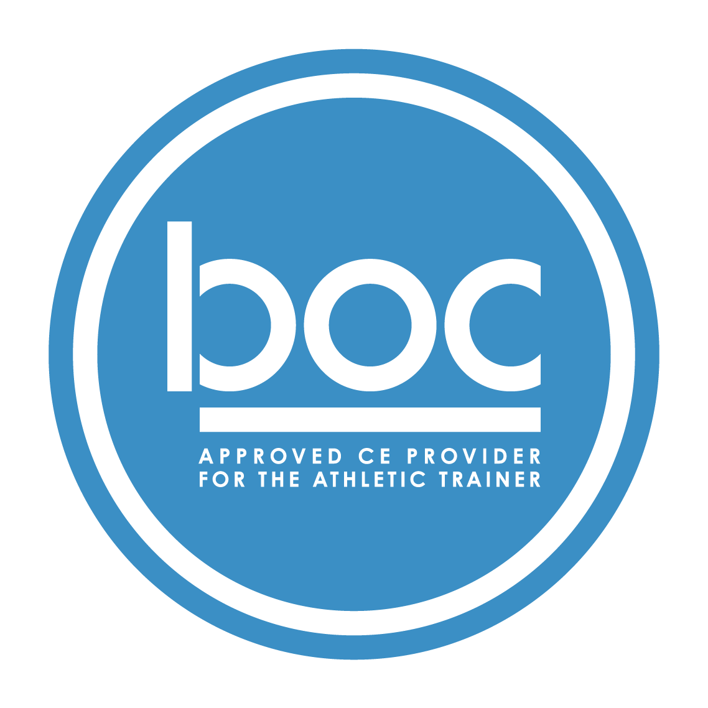  Oklahoma State University Center for Health Sciences Office of Continuing Medical Education (BOC AP#: P12117) is approved by the Board of Certification, Inc. to provide continuing education to Athletic Trainers (ATs). This program is eligible for a maximum of (1.00) Category A hours/CEUs. ATs should claim only those hours actually spent in the educational program.
  Jill Joyce, PhD, RD
  ____
  NO REQUIRED MATERIALS OR EQUIPMENT
  ____
  1-HOUR CATEGORY A CEU AVAILABLE
  ____
  TSET Grant
  NO FEES
  ____
  SESSIONS ARE VIRTUAL VIA ZOOM
  OSU CENTER FOR HEALTH SCIENCES
  1111 W 17th St
  Tulsa, OK 74107
  918-561-8255
  Register:
  https://redcap.okstate.edu/surveys/?s=3KY39MLMMHKCCHMY
  Website
  https://medicine.okstate.edu/echo/atsm-echo.html

